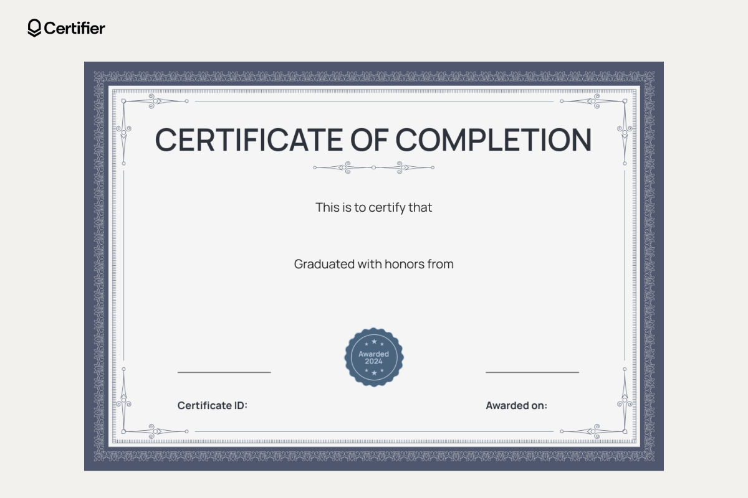
2026-09-05 00:00:00
23CSE005
EEE
Kavya Nair

